SFDCLogin_SFDC_Login_Demo_Instance1_20-Dec-2017_02-52-02_PM_Validation.png

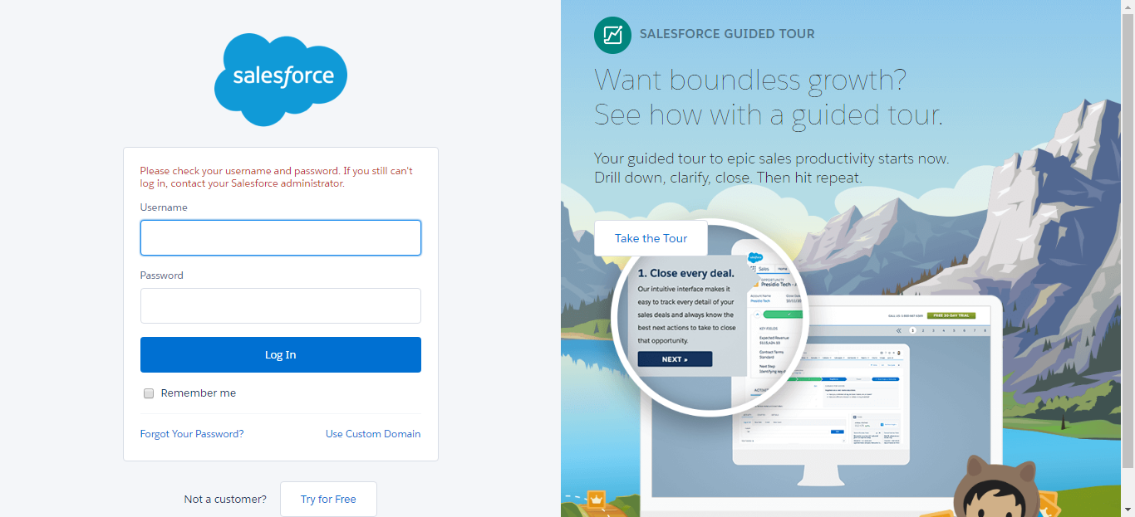

SFDCLogin_SFDC_Login_Demo_Instance1_20-Dec-2017_02-52-39_PM_Validation.png

